Name : Fariha Arai

AF ID : AF0443236

Lab 8

**1. Write a Python program to count the occurrences of each word in a given sentence**

**string = “To change the overall look of your document. To change the look available in the gallery”**

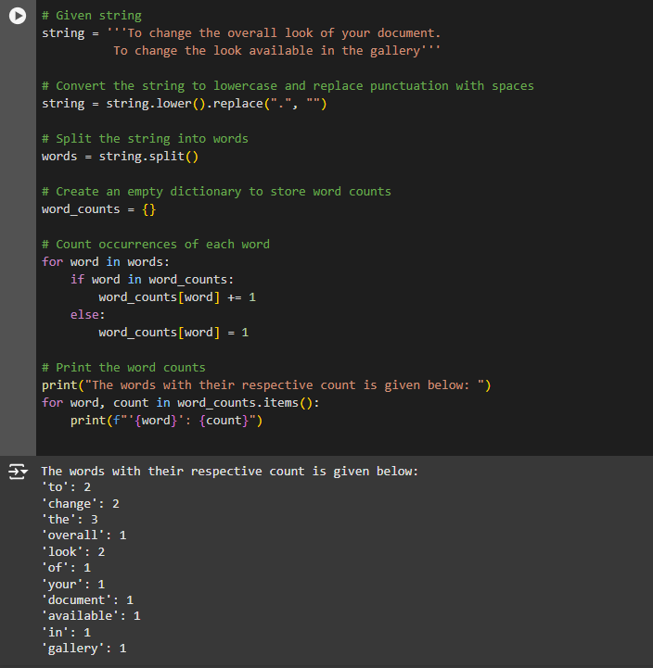

**2. Write a Python program to remove a newline in Python**

**String = "\nBest \nDeeptech \nPython \nTraining\n"**

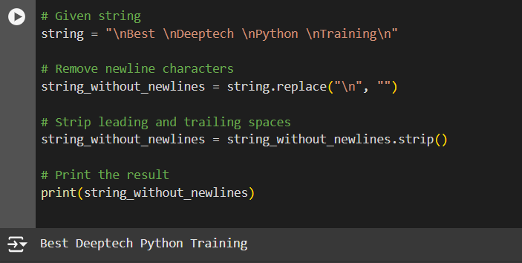

**3. Write a Python program to reverse words in a string**

**String = “Deeptech Python Training”**

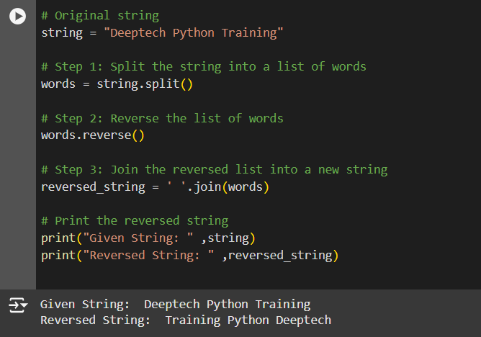

**4. Write a Python program to count and display the vowels of a given text**

**String=”Welcome to python Training"**

